Appium Tutorial

1. What is Appium.
2. Features of Appium.
3. Appium Architecture.
4. Advantages of Appium.
5. Disadvantages of Appium.
6. How Appium works.
7. Types of mobile Applications.
8. Prerequisite to use Appium.
9. Installation of Appium on Windows OS.
10. Limitations of Appium.
11. Competitors of Appium.

* Appium VS Robotium
* Appium VS Selendroid

1. General store application testing.
2. Appium is an open – source automation mobile testing tool.

* It is developed and supported by Sauce Labs to automate native and hybrid mobile apps.
* It is a cross – platform mobile automation tool, which means that it allows the same test to be run on multiple platforms.

1. Features of Appium are –

* Appium does not require application source code or library.
* Appium has multi – platform support.
* Appium has the parallel execution of test scripts.
* Appium supports various languages like C#, Python, Java, Ruby, PHP, Java Script with Node.js.

1. Appium Architecture –

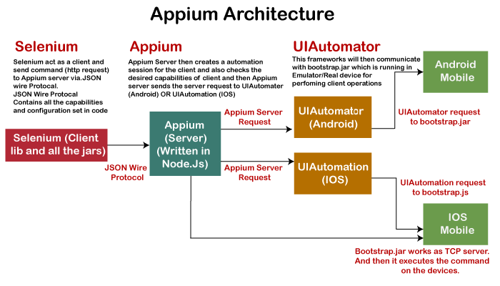

1. Advantages –

* Appium is an open – source tool.
* It allows the automated testing of hybrid, native and web applications.

1. Disadvantages –

* Lack of detailed reports.
* Impossible to run multiple IOS tests on a single MAC device at a single time.

1. How Appium works –

* How Appium works on mobile or android.
* How Appium works on IOS.

Note: Go through with practical, then understand.

1. Types of Mobile applications –

* Native Applications
* Native applications are software programs that are developed by keeping a certain platform in mind.
* Native apps are developed using a specific SDK (Software Development Kit).
* These native apps are developed for use on a specific device and can be installed from the App Store, such a play store.
* Web Applications
* Web applications are not real applications, they are websites that run on browsers.
* These are developed by using HTML, CSS and Java Script.
* Hybrid Applications
* Hybrid application is a combination of native and web applications.
* These applications are also developed by HTML, CSS and Java Script.

1. Prerequisites of Appium –

* Install Java (JDK) latest version from <https://www.oracle.com/in/java/technologies/downloads/> and set path in environment variables.
* Eclipse – Install eclipse from <https://www.eclipse.org/downloads/> and open it.
* Download Android Studio from <https://developer.android.com/studio> and install and open it.
* Create on project with java or Katlin language and check SDK manager is available under Tools section in android studio and set path in system environment.
* Download NodeJS from <https://nodejs.org/en/download/> and install and check the version of node in command prompt using node -v. NodeJS version should be minimum 16.
* Download Appium Desktop server from <https://github.com/appium/appium-desktop/releases/tag/v1.22.3-4> and install and start the server.
* Create one virtual device in android studio.
* Set all the path as shown below:  
  Graphical user interface, text

  Description automatically generated
* Open Path in environment variables and add the paths as shown below:  
  Graphical user interface, text, application, email

  Description automatically generated
* Download Appium Inspector.
* Create one Virtual Device on Android Studio.
* Step – 1: Open android studio and click on Device Manager.
* Step – 2: In device manager, click on ‘Create device’.
* Step – 3: Select category, name of the device and click on Next.

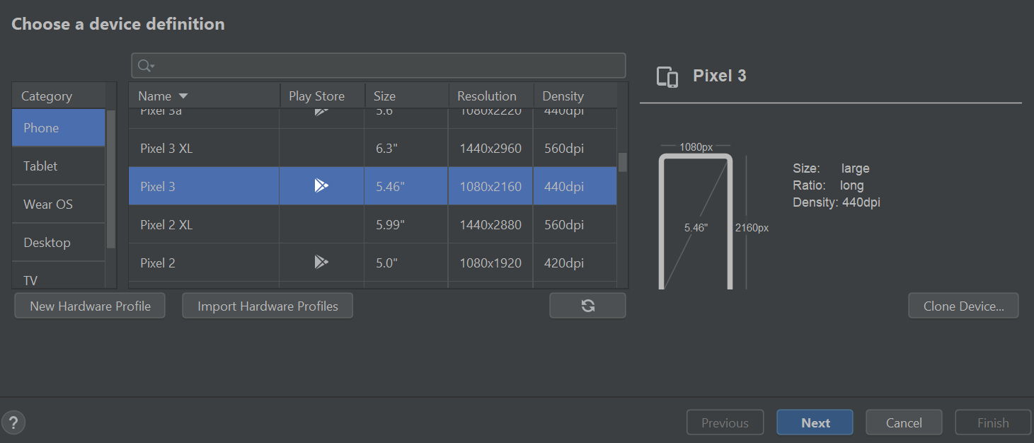

* Step – 4: Select the System image and click on Next.

* Step – 5: Modify the ‘Verify Configuration’ tab and click on Finish.

* Step – 6: Now we can be able to see the New virtual device is created.

1. Installation of Appium on windows OS

* Step – 1: Go to the following link <http://appium.io/> and click on the Download Appium button.

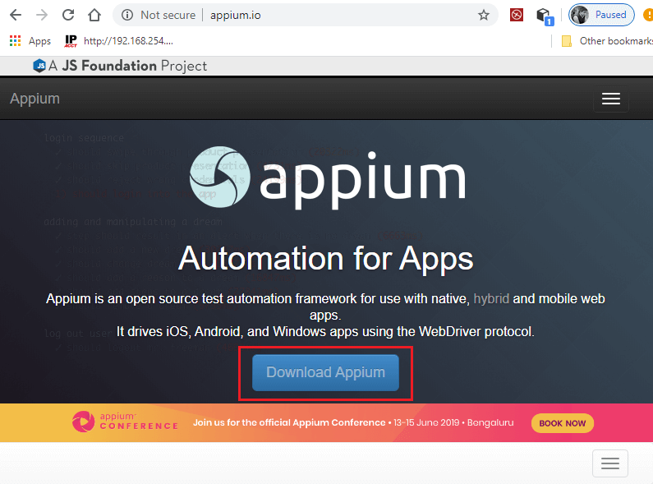

* Step – 2: For Windows OS, download the exe file of Appium desktop setup. So, click on the file as shown in below screenshot.

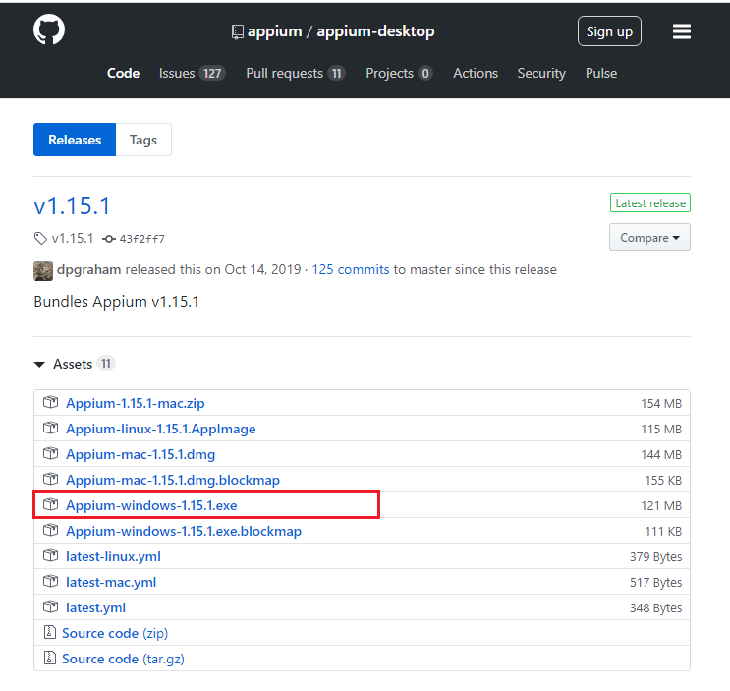

* Step – 3: After downloading the exe file, double click on the downloaded file to run.

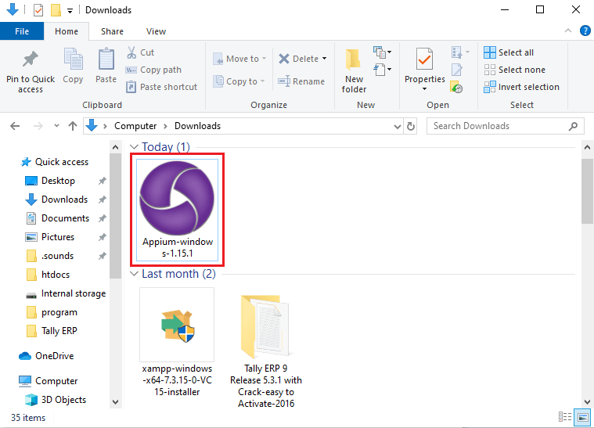

* Step – 4: Here, you need to choose the installation options. You can select all users, if you have multiple users on your system, otherwise select only me for the administrator of the system.

After choosing the installation option, click on the install button.

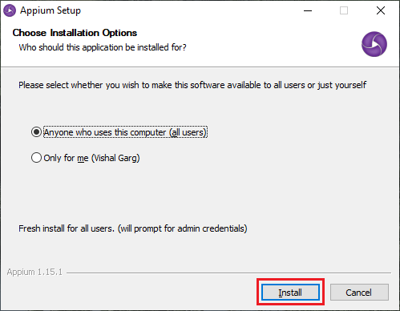

* Step – 5: Appium has been successfully installed on your system. For completing Appium setup, click on the Finish button.

Note that Run Appium is checked. This will start the Appium Desktop.

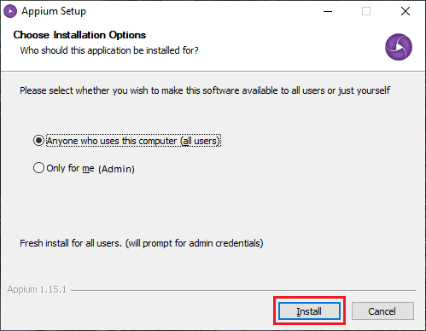

* Step – 6: Now, Appium Desktop UI will appear on the screen containing the default Host and Port, which can be changed.

Default Host - 0.0.0.0

Default Port – 4723

Click on the Start Server button and start Appium Server.

* Step – 7: A new server will launch on the Host and Port specified in previous step. You can see the message on the top of the screen that Server is running.

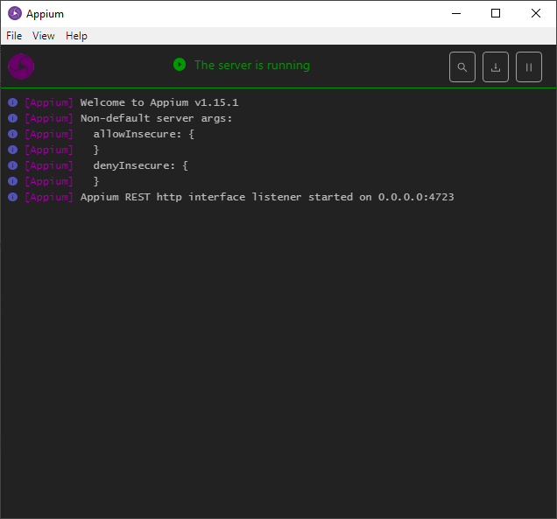

* Step – 8: Go to File and click on the New Session Window.

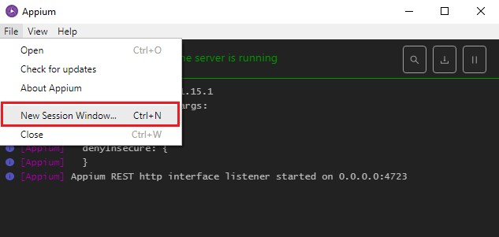

* Step – 9: Provide all desired capabilities here and Click on the Start Session button to start a new session.

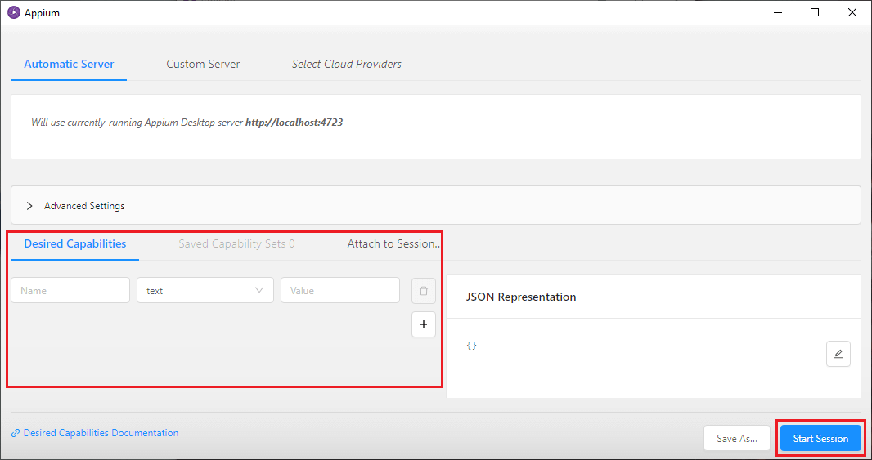

1. Limitations –

* Microsoft Windows does not support running Appium Inspector.
* Appium does not allow the testing of Android versions lower than 4.2.

1. Selendroid and Robotium are the top competitors of Appium.

* Appium VS Robotium –
* Appium is a cross platform that supports both Android and IOS. But Robotium supports only Android.
* Appium supports various languages while Robotium only supports java programming language.
* Appium can be used to test native, hybrid and web applications, whereas Robotium only supports native and hybrid apps.
* Appium VS Selendroid –
* Appium is an open – source automation tool that supports both IOS and Android, whereas Selendroid is a test automation framework that only supports Android.
* In Appium, a small change doesn’t require reinstallation of application. But Selendroid requires reinstallation of the application.

1. Go through with “GITHUB” code.

<https://github.com/wpar2217/Appium_Android_Sample.git>